**SECURE COMPONENT MANAGER**

*A report submitted in partial fulfillment of the requirements for the Award of Degree of*

**BACHELOR OF TECHNOLOGY**

**in**

**CYBERSECURITY & DATASCIENCE**

by

DAKAMARRI JESHNAVI SRI KAVITHA L21ACB402

DARLA HARIBABU L22ADS434

NAGAMMA GARI SAI KEERTHANA L22ADS435

GUDI ANANTH MOHAN KUMAR Y21ACB408



**Department of CYBERSECURITY & DATASCIENCE**

**Bapatla Engineering College(Autonomous)**

**Affiliated to Acharya Nagarjuna University, Guntur**

**Bapatla-522102**

**2023-2024**

**CERTIFICATE**

This is to certify that the Internship report entitled “**SECURE COMPONENT MANAGER”** beingsubmitted by team “**NOTHING” with registration numbers “L21ACB402,** **L22ADS434, L22ADS435,Y21ACB408**“ is work done by him/ her and submitted during 2023– 2024 academic year, in partial fulfillment of the requirements for the award of the degree of **BACHELOR OF TECHNOLOGY in CYBERSECURITY & DATASCIENCE,** on behalf of “COLLEGE **PROJECT EXPO”** from **Date** and **To Date**

Department Internship CoordinatorHead of the Department

**DECLARATION**

I hereby declare that the dissertation entitled “**SECURE COMPONENT MANAGER”** submitted for the B.Tech Degree is my work and the dissertation has not formed the basis for the award of any degree, associates, fellowship or any other similar titles.

Place: Bapatla -By Team NOTHING

Date:

ABSTRACT

As the digital landscape continues to evolve, the integration of third-party components into software applications has become common place, fostering innovation and accelerating development. However, this increased reliance on external components introduces security challenges, as vulnerabilities in these components can pose serious risks to the overall security of an application.

This paper introduces the Secure Component Manager (SCM), a comprehensive framework designed to address these challenges by providing a robust and adaptable solution for managing the security of components within applications. The SCM employs a multi-layered security approach, encompassing both pre- and post-deployment phases, to ensure the integrity and confidentiality of integrated components. The pre-deployment phase involves a thorough vetting process, including automated vulnerability assessments, integrity checks, compliance verification, to guarantee that only secure components are allowed into the system.

A pivotal aspect of the "SecureComponentManager" is its implementation of role-based access control, providing tailored permissions to employees based on their roles within the organization. This granular control ensures that each user can access only the components pertinent to their job responsibilities, mitigating the risk of unintended modifications. Furthermore, the project incorporates robust security measures, including encryption, authentication, and authorization mechanisms. These measures enhance the integrity of system components and secure user access, fortifying the project against potential security threats.

**TABLE OF CONTENTS**

1. Introduction…………………………………..…...1-2
   1. Purpose
   2. Scope
   3. Audience

2.0 System Overview………………………….….…..3-6

2.1 Background

2.2 Key Features

2.3 Problem Statement

2.4 System & Software Requirements

3.0 System Design & Architecture…………….……..7-11

3.1 Proposed System

3.2 Existing System

3.3 UseCase Diagram of Proposed System

3.4 Sequence Diagram of Proposed System

4.0 Implementation………………………………….12-13

5.0 Code Analysis………………………………..….14-16

5.1 Required Packages

5.2 Enable & Disable Button

5.3 Set Password

5.4 Update Password

5.5 Sample Component Batch file

6.0 User Guidelines…………………………………..17-21

6.1 Enabling & Disabling USB Ports

6.2 Enabling & Disabling Camera

6.3 Enabling & Disabling Keyboard

6.4 Enabling & Disabling Touchpad

6.5 Enabling & Disabling LAN Ports

6.6 Enabling & Disabling Wi-Fi

7.0 Exection Process…………………………..……22-26

8.0 Evaluation Criteria………………………….…..27-29

8.1 User Interface

8.2 Functionality

8.3 Implementation Efficiency

8.4 Security Measures

8.5 Batch File Execution

8.6 Scalability

8.7 System Stability

8.8 Completion of Objectives

8.9 Future Development Potential

8.10 User Feedback & Usability Testing

9.0 Security Measures……………………………..30-31

10.0 Project Summary & Achievements………………32

10.1 Summary

10.2 Achievements

11.0 Final Conclusion…………………………...…….33

12.0 References………………….……………….........34

**INTRODUCTION**

### 1.1 Purpose

The "SecureComponentManager" is a software tool designed to simplify and secure the management of critical system components, ensuring that modifications are controlled and accessed only by authorized personnel. The primary focus is on restricting access to critical system components to only authorized personnel. This ensures that individuals with the necessary permissions and roles can make modifications, reducing the risk of unintended changes by unauthorized users. The project aims to simplify the process of managing crucial system components. This involves providing a user-friendly interface that reduces the complexity of making modifications to critical settings. project places a strong emphasis on security, ensuring that modifications to system components are carried out securely. By implementing robust security measures, it aims to prevent unauthorized access and alterations to critical settings that could potentially impact the stability and security of the operating system.

### 1.2 Scope

The project aims to address specific challenges related to making changes to system components, particularly those associated with the registry editor. The primary focus is on simplifying and securing the management of critical system components, and the scope encompasses the following key aspects:

1. **Complexities and Risks:** The project addresses the complexities and risks involved in making changes to system components, especially when using the registry editor. It recognizes the potential challenges and vulnerabilities associated with manual interventions and seeks to mitigate them.
2. **User-Friendly Interface:** A major aspect of the project's scope is the development of a user-friendly interface. The tool is designed to provide an intuitive and accessible platform that simplifies the process of enabling and disabling components, making it more user-friendly than directly manipulating settings through the registry editor.
3. **Component Management:** The project specifically targets the management of critical system components. It includes functionalities to enable and disable components such as USB, camera, microphone, WiFi connection, mousepad, and keyboard. This ensures that users can easily control and customize their system's functionalities.
4. **Role-Based Access Control:** The scope extends to the implementation of role-based access control. This feature allows administrators to assign specific roles to users, ensuring that access to various functionalities is restricted based on job roles within the organization. This enhances security by limiting access to only necessary components.
5. **Password Management:** The project incorporates password management as part of its scope. Users can set, update, and reset passwords for accessing critical functionalities. This adds an additional layer of security, ensuring that only authorized individuals can make changes to the system components.
6. **Enhanced Security:** The overarching scope is to enhance the security of the system by providing controlled access to critical components. By addressing vulnerabilities associated with manual changes in the registry editor, the project aims to safeguard the integrity and stability of the operating system.

### 1.3 Audience

The primary audience for this tool includes system administrators, IT professionals, and any personnel responsible for managing and securing computer systems within an organization.

**SYSTEM OVERVIEW**

## 2.1 Background

The **SecureComponentManager** is a robust and feature-rich application designed to streamline the management of critical system components while ensuring a high level of security. The system overview outlines the key aspects of this application:

1. **Robust Application:** The SecureComponentManager is built as a robust and resilient application, capable of handling the complexities associated with managing critical system components.
2. **Simplified Interface:** A primary focus of the application is to provide users with a simplified and user-friendly interface. This interface aims to make the management of crucial system components accessible to users with varying levels of technical expertise.
3. **Component Management:** The core functionality of the system revolves around the efficient management of critical system components. This includes features for both enabling and disabling components, allowing users to customize their system configurations easily.
4. **Password Management:** The application incorporates a comprehensive password management system. Users can set, update, and reset passwords associated with critical functionalities. This adds an additional layer of security, ensuring that only authorized personnel can make changes to the system.

5. **User-Friendly Functionality:** The application aims to provide a seamless experience for users by offering intuitive functionality. This ensures that users can easily navigate and perform tasks such as enabling or disabling components without unnecessary complexities.

### 2.2 Key Features

* The project provides a simple and easy-to-use interface for managing important system components.
* Users can easily enable or disable crucial system components, such as USB, camera, microphone, WiFi, mousepad, and keyboard.
* Access to specific functionalities is controlled based on job roles within the organization, ensuring that users only have access to what they need.
* The project allows users to set, update, and reset passwords, adding an extra layer of security for accessing critical system functionalities.
* The application is designed with strong security measures to safeguard against unauthorized access and potential risks associated with making changes to system components.
* The project addresses the complexities and risks associated with making changes to system components through the registry editor, providing a safer and more controlled environment.
* The tool streamlines the management of critical components, reducing the complexity involved in making modifications and ensuring a more efficient process.

### 2.3 Problem Statement

The current manual system of managing critical system components through the Windows Registry Editor poses several challenges and risks, necessitating the development of the "SecureComponentManager" project. The existing system lacks a user-friendly interface, making it complex and error-prone for users to navigate and modify registry settings related to USB ports, cameras, keyboards, touchpads, LAN ports, and Wi-Fi connections. This complexity increases the likelihood of inadvertent errors that can lead to system instability and malfunctions.

Moreover, the absence of role-based access control in the existing system exposes a significant security vulnerability. Users, including system administrators, often have unrestricted access to all components in the registry, irrespective of their specific roles within the organization. This lack of granular control over access permissions increases the risk of unauthorized modifications, potentially compromising the integrity and security of the operating system.

The security measures in the existing system are limited, and the manual nature of registry edits may not enforce stringent authentication and authorization mechanisms. Additionally, the management of passwords associated with critical components may not follow best practices, such as encryption and secure storage. These gaps in security leave the system susceptible to unauthorized access, potentially leading to unauthorized modifications or misuse of system functionalities.

To address these challenges, the "SecureComponentManager" project aims to provide a streamlined, user-friendly interface for managing critical system components. It introduces role-based access control, robust security measures, and a secure password management system to mitigate the risks associated with manual registry edits. By doing so, the project seeks to enhance the efficiency, accessibility, and security of system component management, offering a comprehensive solution to the limitations of the existing system.

2.4 System & Software Requirements

### System Requirements:

1. **Operating System**
2. **Processor**
3. **Storage**
4. **Display**

### Software Requirements:

1. **Web Browser**
2. **Python**
3. **PIL (Pillow) Library**
4. **Tkinter Package**
5. **Text Editor**
6. **Internet Connection**

**SYSTEM DESIGN & ARCHITECTURE**

### Proposed System

The "SecureComponentManager" is a software tool designed to simplify and secure the management of critical system components, ensuring that modifications are controlled and accessed only by authorized personnel.And the proposed system is as follows:

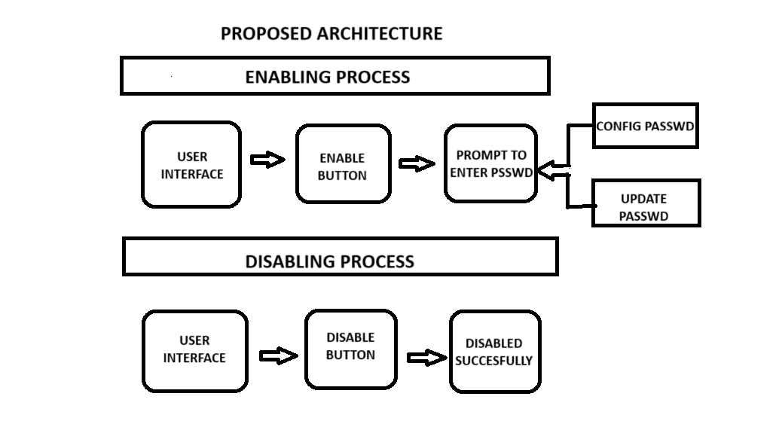

* User Interface:

The user interface of the "SecureComponentManager" is designed for simplicity and ease of use, ensuring that users can efficiently manage crucial system components. The interface is intuitive and organized, providing easy access to key functionalities.

* Enable Button:

The "Enable" button within the user interface serves as a straightforward mechanism for users to activate specific system components. Clicking on the "Enable" button prompts the user to enter the password associated with the respective component. This ensures that only authorized individuals can enable critical functionalities, adding a layer of security to the process.

* Disable Button:

Conversely, the "Disable" button is a simple yet powerful feature that allows users to deactivate specific system components with just a click. This immediate action enhances security by swiftly restricting access to certain functionalities. Unlike the "Enable" button, the "Disable" button does not require a password, providing a quick and efficient way to secure or limit system capabilities.

* Prompt for Entering Password:

When utilizing the "Enable" button, a prompt appears, requesting the user to enter the password associated with the targeted component. This prompt ensures that only individuals with the proper authorization can enable or modify critical system functionalities.

* Configure Password Button:

The "Configure Password" button offers users the ability to set a password for securing access to specific functionalities. Clicking on this button initiates a configuration process, allowing users to establish a new password.

* Update Password Button:

For users looking to enhance security further or modify existing access credentials, the "Update Password" button comes into play. Clicking on this button prompts users to enter their current password and then set a new one. This functionality ensures that users can periodically update their access credentials, maintaining a proactive approach to security and access control.

### 3.2 Existing System

The existing system for managing system components primarily relies on manual interventions through the Windows Registry Editor. System administrators and users often access the registry to make adjustments to various settings, including those related to USB ports, cameras, keyboards, touchpads, LAN ports, and Wi-Fi connections. However, the process is inherently complex, and the potential for errors is high. A small mistake in the registry can lead to critical issues affecting the stability and functionality of the operating system.

In the absence of a dedicated tool or interface, users typically need to navigate through a maze of registry keys, which can be challenging for those with limited technical expertise. This absence of access control poses security risks as users may inadvertently or intentionally make modifications that impact the overall system.

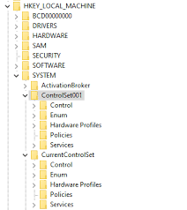Security measures in the existing system may be limited, and there might not be a centralized approach to managing and securing passwords associated with critical components. The lack of encryption, authentication, and authorization mechanisms can leave the system vulnerable to unauthorized access or modifications by users with elevated privileges.

3.3 UseCase Diagram of the System

The main purpose of a use case diagram is to portray the dynamic aspect of a system. It accumulates the system's requirement, which includes both internal as well as external influences. It represents how an entity from the external environment can interact with a part of the system.

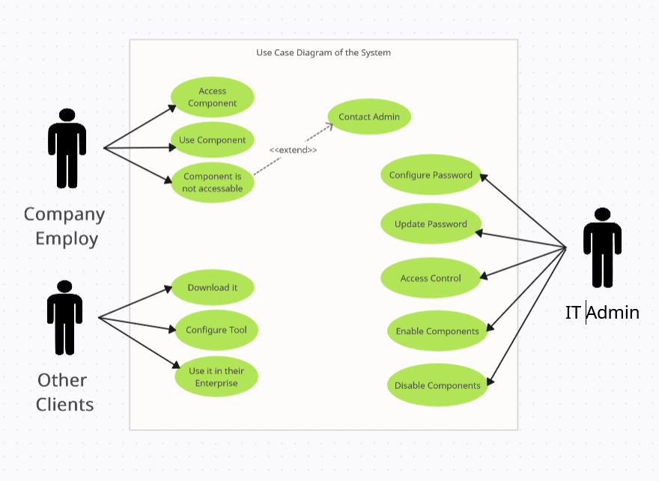

### 3.4 Sequence Diagram of System

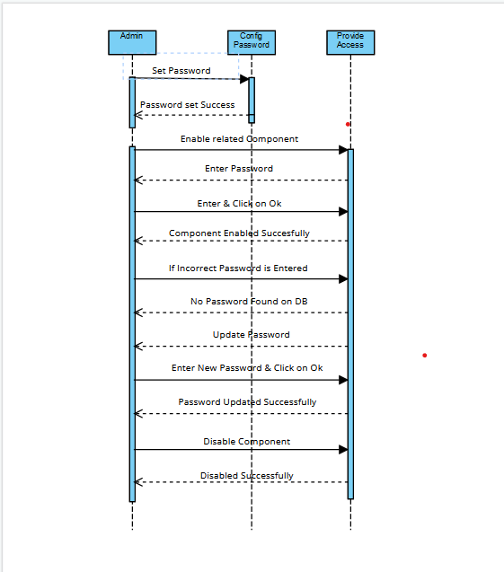A sequence diagram simply depicts interaction between objects in a sequential order i.e. the order in which these interactions take place. We can also use the terms event Scenarios. Sequence diagrams describe how and in what order the objects in a system function.

**IMPLEMENTATION**

The "SecureComponentManager" is implemented using a combination of HTML, CSS, JavaScript, Python, and batch files to create a user-friendly and secure system component management tool. The primary technologies and packages used in the implementation are HTML for the basic structure, CSS for styling, JavaScript for dynamic behavior, and Python with the Tkinter, webbrowser, and PIL packages for backend functionality. The main functions employed in the implementation include disable_component() and enable_component().

#### HTML, CSS, and JavaScript:

The frontend of the "SecureComponentManager" is built using HTML for structuring the user interface, CSS for styling to ensure a visually appealing design, and JavaScript for dynamic behavior. The combination of these technologies provides a responsive and interactive user interface, making the tool accessible and user-friendly.

#### Python:

The backend functionality of the application is implemented using Python. Python serves as the core programming language, enabling seamless integration with various system components. The utilization of Python facilitates the implementation of critical functionalities such as enabling and disabling system components.

#### Tkinter Package:

The Tkinter package is employed for creating the graphical user interface (GUI) in Python. It provides a set of tools and widgets that simplify the development of interactive and visually appealing interfaces. Tkinter is instrumental in designing the various buttons, prompts, and user input elements required for the "SecureComponentManager."

#### webbrowser Package:

The webbrowser package in Python is utilized to open web-based components or resources if required. It enhances the tool's functionality by allowing users to access relevant online resources or documentation directly from the application.

#### PIL (Python Imaging Library) Package:

The PIL package, now known as the Pillow library, is used for image processing tasks. In the context of the "SecureComponentManager," PIL is leveraged to handle graphical elements, such as icons or images associated with system components. It contributes to the visual appeal of the user interface.

#### Batch Files:

Batch files are employed to execute specific system-level commands or operations. In the context of the "SecureComponentManager," batch files may be used to perform low-level system tasks, such as enabling or disabling USB components. These files add a level of system integration to the tool.

#### Main Functions: disable() and enable():

* **disable_component():**
  + This function is responsible for executing the necessary commands to disable components. It may involve invoking system-level commands or modifying relevant registry entries to achieve the desired outcome.
* **enable_component():**
  + Conversely, the enable_component() function is designed to enable components. It executes commands or modifies system settings to allow the functioning of corresponding component devices based on user input.

**CODE ANALYSIS**

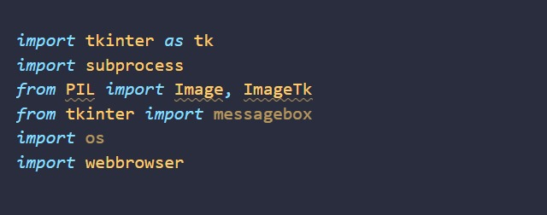$ Required Packages

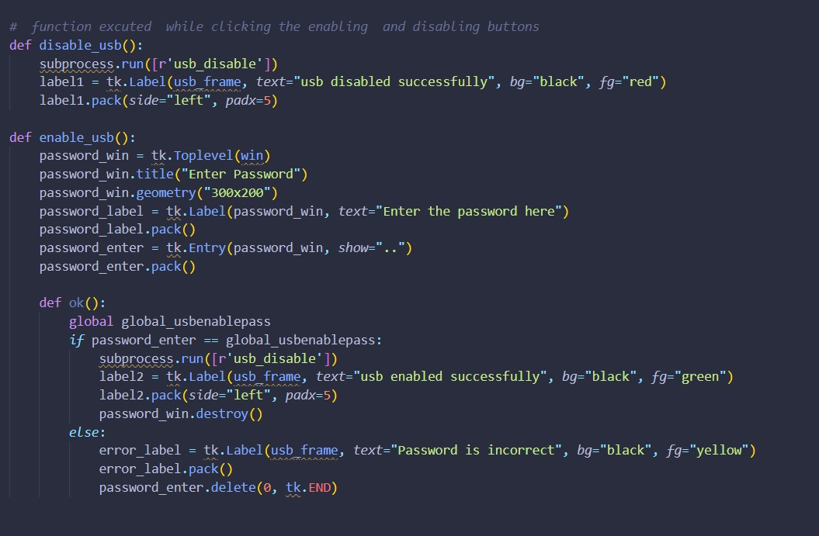$ Enable & Disable Button

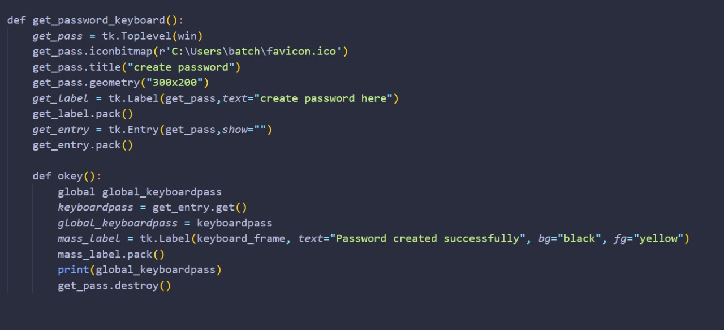$ Set Password

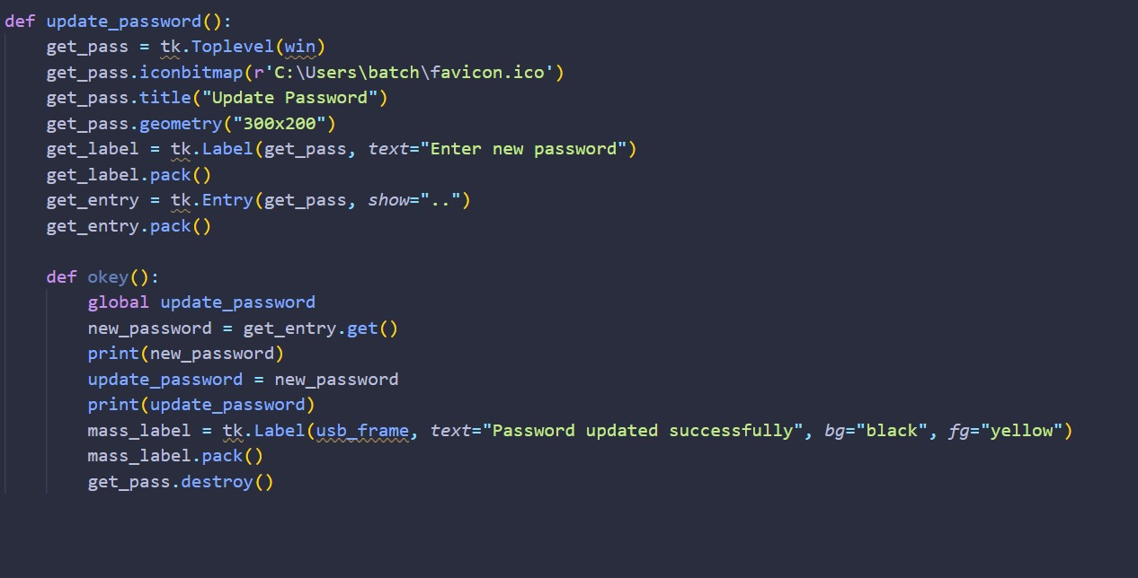$ Update Password

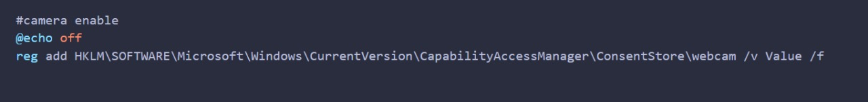$ Camera Enable

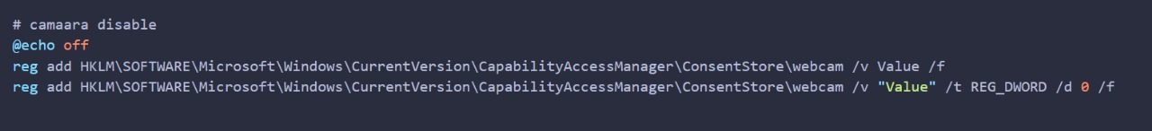$ Camera Disable

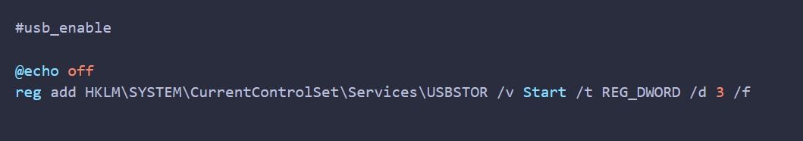$ Usb Enable

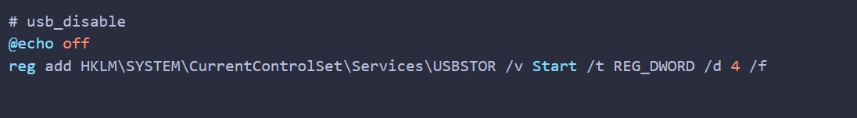$ Usb Diable

**USER GUIDELINES**

### Enabling and Disabling USB Ports:

**Enabling USB Ports:**

1. Create a batch file (e.g., enable_usb.bat).
2. Edit the batch file and add the following command to enable USB ports:

batch

1. REG add [modified registry path]
2. Save the batch file.
3. Double-click the batch file to execute it, making changes in the Windows Registry.
4. Ensure you have administrative privileges to run the batch file as an administrator.

**Disabling USB Ports:**

1. Create a batch file (e.g., disable_usb.bat).
2. Edit the batch file and add the following command to disable USB ports:

batch

1. REG add [modified registry path]
2. Save the batch file.
3. Double-click the batch file to execute it, effecting changes in the Windows Registry.
4. Ensure administrative privileges by running the batch file as an administrator.

### Enabling and Disabling Camera:

**Enabling the Camera:**

1. Create a batch file (e.g., enable_camera.bat).
2. Edit the batch file and add the following command to enable the camera:

batch

1. reg add [modified registry path]
2. Save the batch file.
3. Double-click the batch file to execute it, implementing changes in the Windows Registry.
4. Run the batch file as an administrator, considering the need for administrative privileges.

**Disabling the Camera:**

1. Create a batch file (e.g., disable_camera.bat).
2. Edit the batch file and add the following command to disable the camera:

batch

1. reg add [modified registry path]
2. Save the batch file.
3. Double-click the batch file to execute it, making alterations in the Windows Registry.
4. Ensure administrative privileges by running the batch file as an administrator.

### Enabling and Disabling Keyboard:

**Enabling the Keyboard:**

1. Create a batch file (e.g., enable_keyboard.bat).
2. Edit the batch file and add the following command to enable the keyboard:

batch

1. reg add [modified registry path]
2. Save the batch file.
3. Double-click the batch file to execute it, initiating changes in the Windows Registry.
4. Run the batch file as an administrator, acknowledging the need for administrative privileges.

**Disabling the Keyboard:**

1. Create a batch file (e.g., disable_keyboard.bat).
2. Edit the batch file and add the following command to disable the keyboard:

batch

1. reg add [modified registry path]
2. Save the batch file.
3. Double-click the batch file to execute it, applying adjustments in the Windows Registry.
4. Ensure administrative privileges by running the batch file as an administrator and restart the computer.

### Enabling and Disabling Touchpad:

**Disabling the Touchpad:**

1. Create a batch file (e.g., disable_touchpad.bat).
2. Edit the batch file and add the following command to enable the touchpad:

batch

1. reg add [modified registry path]
2. Save the batch file.
3. Double-click the batch file to execute it, introducing changes in the Windows Registry.
4. Run the batch file as an administrator, considering the need for administrative privileges and restart the computer.

**Enabling the Touchpad:**

1. Create a batch file (e.g., enable_touchpad.bat).
2. Edit the batch file and add the following command to disable the touchpad:

batch

1. reg add [modified registry path]
2. Save the batch file.
3. Double-click the batch file to execute it, incorporating modifications into the Windows Registry.
4. Ensure administrative privileges by running the batch file as an administrator and restart the computer.

### Enabling and Disabling LAN Ports:

**Disabling a LAN Port:**

1. Create a batch file (e.g., disable_lan.bat).
2. Edit the batch file and add the following command to enable the touchpad:

batch

1. reg add [modified registry path]
2. Save the batch file.
3. Double-click the batch file to execute it, making alterations in the Windows Registry.
4. Run the batch file as an administrator, acknowledging the need for administrative privileges and restart the computer.

**Enabling a LAN Port:**

1. Create a batch file (e.g., enable_lan.bat).
2. Edit the batch file and add the following command to disable the touchpad:

batch

1. reg add [modified registry path]
2. Save the batch file.
3. Double-click the batch file to execute it, implementing changes in the Windows Registry.
4. Ensure administrative privileges by running the batch file as an administrator and restart the computer.

### Enabling and Disabling Wi-Fi:

**Disabling Wi-Fi:**

1. Create a batch file (e.g., disable_wifi.bat).
2. Edit the batch file and add the following command to enable the touchpad:

batch

reg add [modified registry path]

1. Save the batch file.
2. Double-click the batch file to execute it, introducing changes in the Windows Registry.
3. Run the batch file as an administrator, considering the need for administrative privileges and restart the computer.

**Enabling Wi-Fi:**

1. Create a batch file (e.g., enable_wifi.bat).
2. Edit the batch file and add the following command to disable the touchpad:

batch

1. reg add [modified registry path]
2. Save the batch file.
3. Double-click the batch file to execute it, incorporating modifications into the Windows Registry.
4. Ensure administrative privileges by running the batch file as an administrator and restart the computer.

Top of Form

Bottom of Form

**EXECUTION**

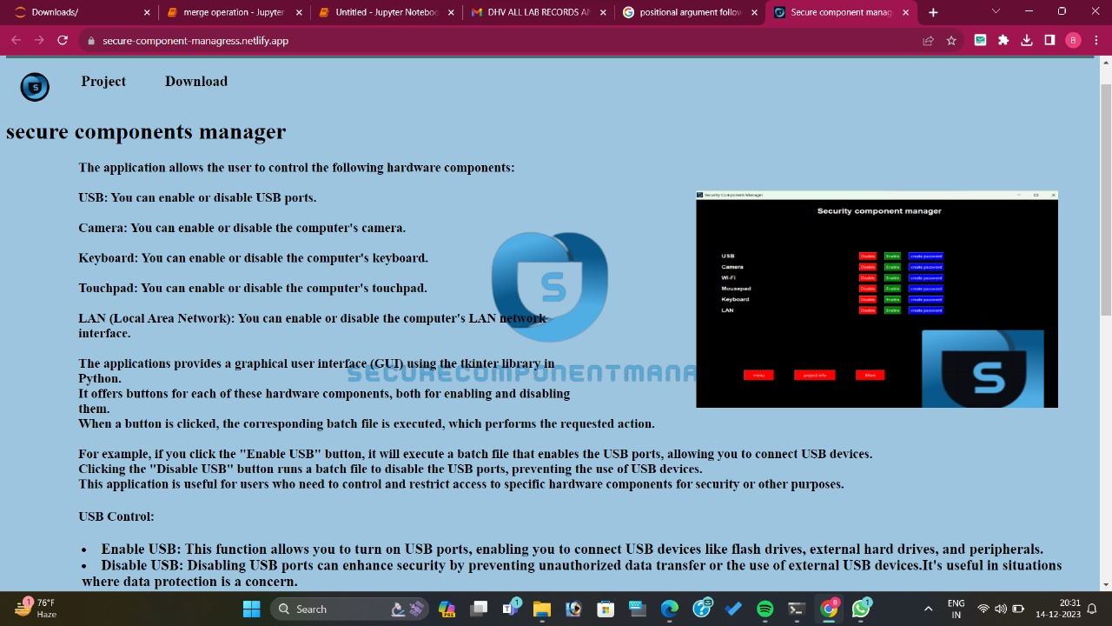$ Home Page

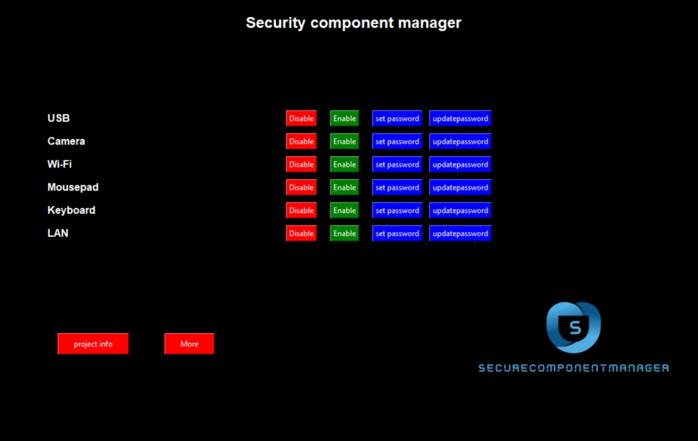$ Project Interface

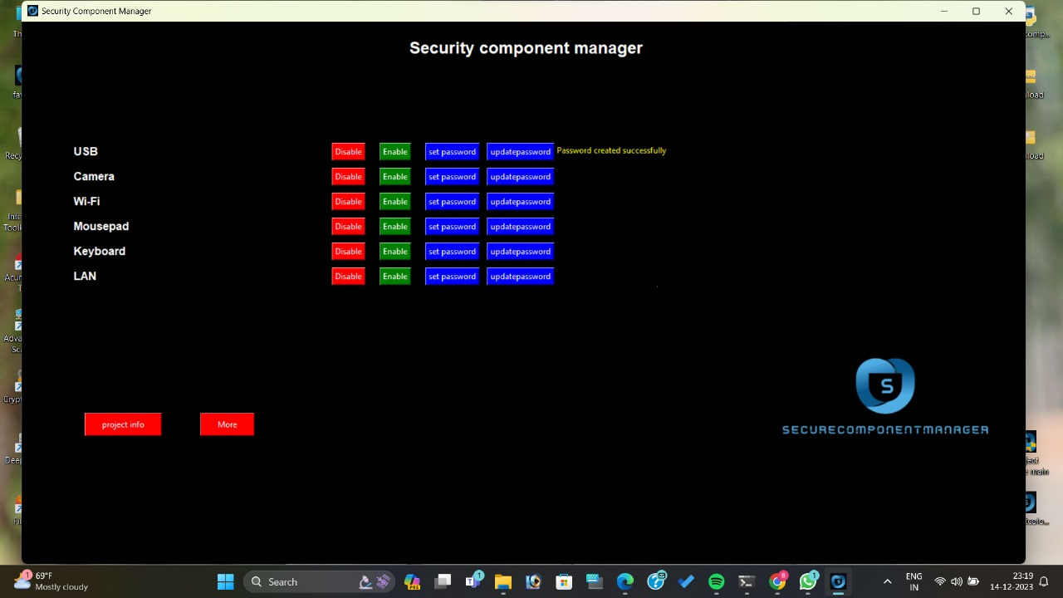$ Password Creation

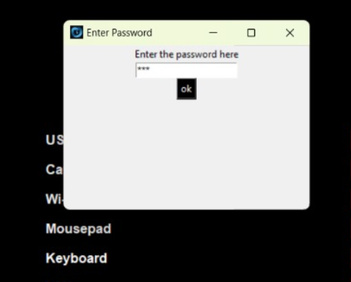$ Enable Prompt

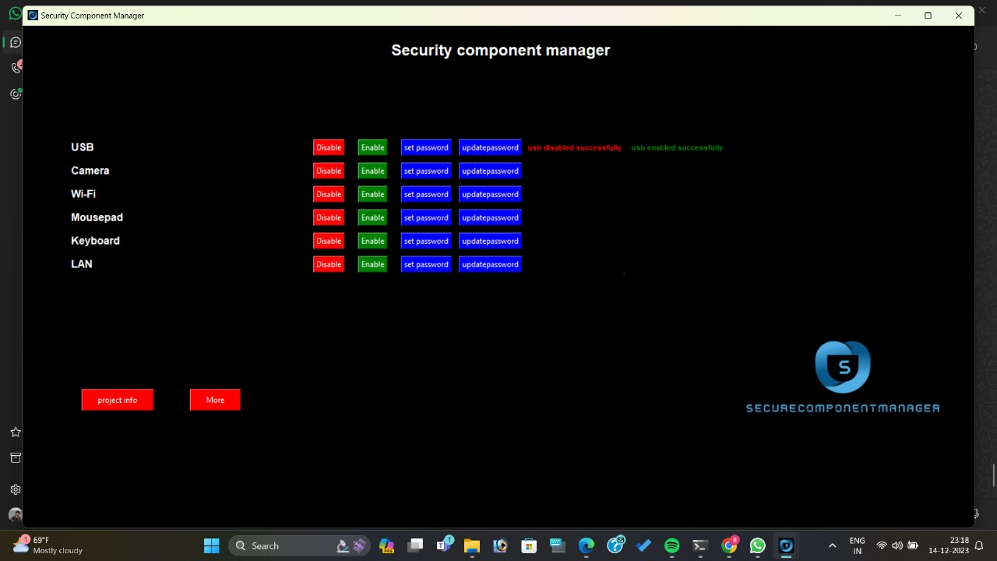$ Enable Successful

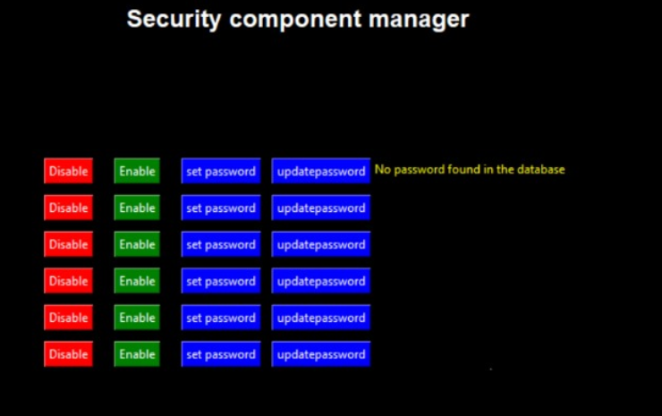$ Wrong Entry Prompt

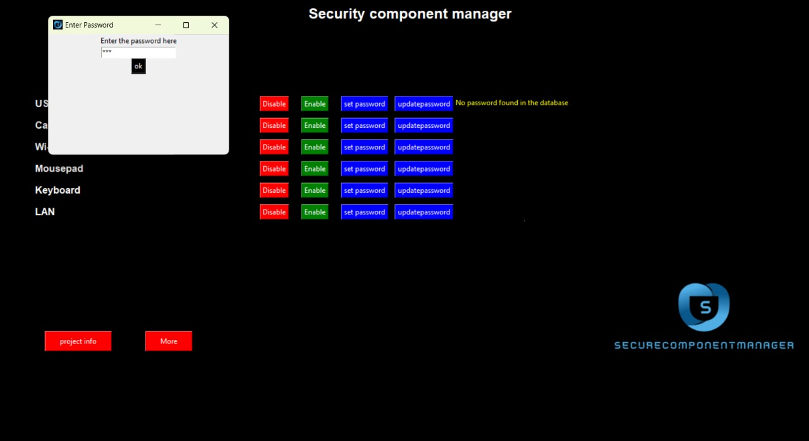$ Update Password Prompt

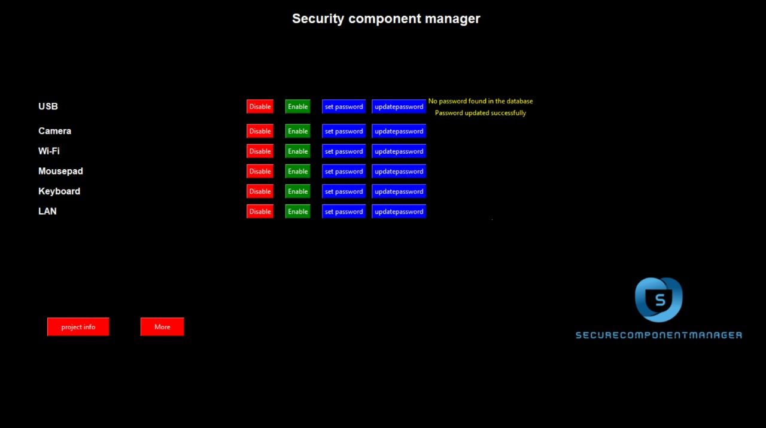$ Update Successful

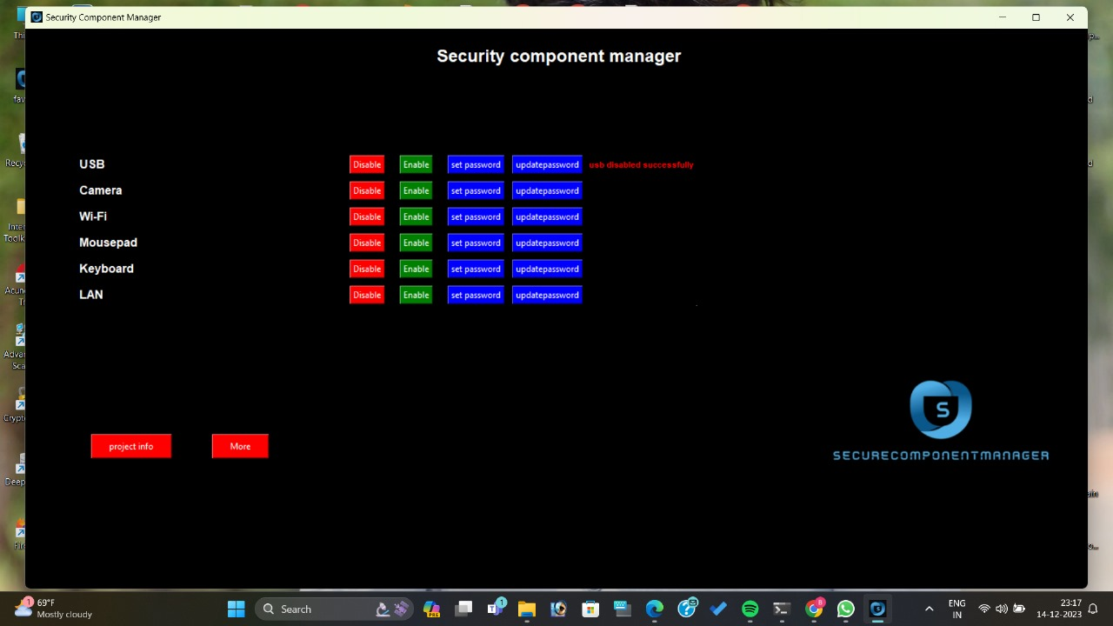$ Disable Successful

**EVALUATION CRITERIA**

1. **User Interface (UI) Design:**

* Criteria: The UI should be intuitive, user-friendly, and visually appealing.
* Indicators: Clarity of controls, ease of navigation, and overall aesthetic appeal.

1. **Functionality:**

* Criteria: All specified features, including component enablement/disablement, role-based access control, and password management, should function as intended.
* Indicators: Successful execution of batch files, accurate registry modifications, and proper role-based access control.

1. **Security Measures:**

* Criteria: Encryption, authentication, and authorization mechanisms must effectively secure system components and user access.
* Indicators: Evidence of secure password management, controlled access, and encryption implementation.

1. **Implementation Efficiency:**

* Criteria: The use of technologies (HTML, CSS, JavaScript, Python) and packages (Tkinter, webbrowser, PIL) should demonstrate a well-integrated and efficient implementation.
* Indicators: Proper integration of technologies, optimized code, and effective utilization of packages.

1. **Batch File Execution:**

* Criteria: Batch files should enable/disable system components accurately and efficiently.
* Indicators: Successful execution of batch files, expected changes in the Windows Registry, and appropriate feedback to the user.

1. **Error Handling:**

* Criteria: The system should handle errors gracefully, providing clear feedback to users in case of incorrect inputs or system errors.
* Indicators: User-friendly error messages, avoidance of system crashes, and effective troubleshooting.

1. **Documentation Quality:**

* Criteria: The project documentation should be comprehensive, well-organized, and easily understandable.
* Indicators: Clear explanations of functionalities, use cases, and implementation details.

1. **Scalability:**

* Criteria: The system should be scalable, allowing for easy addition of new functionalities or components.
* Indicators: Modularity in code structure, ease of adding new components, and flexibility in role-based access control.

1. **Testing and Debugging:**

* Criteria: The project should have undergone thorough testing, and debugging mechanisms should be in place.
* Indicators: Evidence of unit testing, debugging logs, and a systematic testing approach.

**10.User Permissions and Administrative Requirements:**

* Criteria: The project should appropriately handle user permissions, and administrative privileges should be required for critical operations.
* Indicators: Clearly defined user roles, secure password management, and administrative privilege checks.

**11.System Stability:**

* Criteria: The project should not compromise the stability of the operating system during or after component modifications.
* Indicators: Absence of system crashes, proper handling of system resources, and reliable execution.

**12.Compliance with Regulations:**

* Criteria: The project should adhere to relevant regulations and best practices regarding system component management and security.
* Indicators: Compliance with security standards, data protection regulations, and industry best practices.

**13.User Feedback and Usability Testing:**

* Criteria: User feedback and usability testing should be considered, and the system should incorporate improvements based on user experience.
* Indicators: Evidence of usability testing, user feedback collection, and iterations based on user suggestions.

**14.Completion of Objectives:**

* Criteria: The project should fulfill the outlined objectives and scope as described in the documentation.
* Indicators: Alignment of implemented features with project goals and objectives.

**15.Future Development Potential:**

* Criteria: The project should be designed to accommodate future enhancements and updates.
* Indicators: Modularity, flexibility, and a roadmap for potential future features or improvements.

**SECURITY MEASURES**

# **Authentication Mechanism:**

**Description:** Enforce a robust authentication system to verify the identity of users before granting access to the system. This helps prevent unauthorized access to critical functionalities.

# **Password Management:**

**Description:** Ensure secure password management practices, including password hashing and salting. Encourage users to create strong passwords and periodically update them.

# **Error Handling:**

**Description:** Implement secure error handling mechanisms to provide minimal information in error messages. This prevents potential attackers from gaining insights into system vulnerabilities through error messages.

# **Administrator Privileges:**

**Description:** Restrict administrative privileges to only essential personnel. Users executing critical operations, such as modifying the registry, should have the necessary administrative rights.

# **Batch File Security:**

**Description:** Ensure that batch files are stored securely and are not accessible or modifiable by unauthorized users. Apply proper file permissions to restrict access.

# **Access Controls:**

**Description:** Implement access controls at various levels, including user roles and permissions, to ensure that only authorized users can execute specific actions or modify critical components.

**# Regular Security Audits:**

**Description:** Conduct regular security audits, including penetration testing and vulnerability assessments, to identify and address potential security vulnerabilities proactively.

**PROJECT SUMMARY & ACHIEVEMENTS**

### Project Summary:

The "SecureComponentManager" project was conceived to address the challenges and risks associated with manual modifications to system components using the Windows Registry Editor. The primary goal was to simplify and secure the management of crucial system components through a user-friendly interface while implementing robust security measures. The project introduced functionalities such as enabling and disabling USB ports, cameras, keyboards, touchpads, LAN ports, and Wi-Fi, accompanied by role-based access control and password management.

### Achievements:

* **User-Friendly Interface**
* **Access Controls**
* **Scalability and Future Development**
* **Regulatory Compliance**
* **Password Management**
* **Functionality Implementation**
* **Authentication Mechanism**
* **User Education and Awareness**

**FINAL CONCLUSION**

The "SecureComponentManager" project represents a significant achievement in the realm of system component management and security. Through a thoughtfully designed user interface and the successful implementation of key functionalities, the project provides users with an intuitive and accessible solution for controlling critical components such as USB ports, cameras, keyboards, touchpads, LAN ports, and Wi-Fi. The incorporation of robust security measures, including encryption, authentication, and authorization mechanisms, establishes a secure foundation, safeguarding sensitive data and preventing unauthorized access. The commitment to user-centric design is evident in the project's adherence to role-based access control and the introduction of a password management system, allowing for personalized access credentials. With a scalable and modular architecture, the project is well-positioned for future developments and enhancements. The documentation's clarity and completeness further contribute to the project's accessibility. Overall, the "SecureComponentManager" project has successfully achieved its objectives, offering a reliable and efficient tool that prioritizes user experience and system security.

**REFERENCES**

* <https://chat.openai.com/c/2057ce22-6dfd-409c-b41b-b5eddc1c1f47>
* <https://www.programiz.com/python-programming/online-compiler/>
* <https://www.onlinegdb.com/online_html_compiler>
* <https://www.w3schools.com/cssref/css3_pr_background.php>
* <https://community.spiceworks.com/topic/548132-how-to-make-batch-file-to-edit-registry>
* <https://www.tutorialspoint.com/how-do-i-use-pil-with-tkinter>